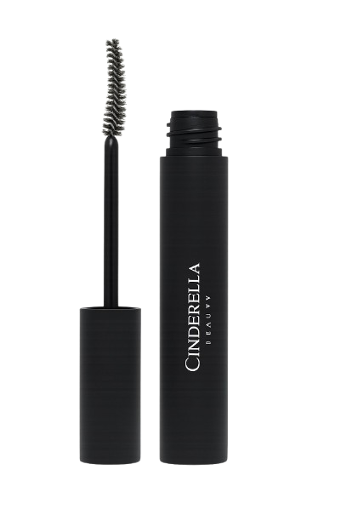
Name : Volume mascara
Description : Volume mascara makes eyelashes look thicker, fuller, and darker. It adds volume to the lashes and makes the eyes look bigger and more defined. It is suitable for daily and party makeup.
How to use :
- Start with clean, dry eyelashes.
- Apply mascara from the root of the lashes to the tips.
- Move the brush in a zig-zag motion for more volume.
- Apply a second coat if you want extra thickness.

